**GUDFAMA ASSISTANCE FARMING AGREEMENT**

**THIS AGREEMENT** is made this day of 2024.

**BETWEEN**

**GLADIUS URBAN FARM AFRICA** a business name duly registered under the Companies and Allied Matters Act 2020 with its registered office located at No.13 Rumuodaolu Market Road, Off Rumuola Road. Port harcourt, Rivers-State. (Herein referred to as Gladius) of the one part.

**AND**

Mr/Mrs/Miss of No. (Herein referred to as Gudfama), of the other part.

**NOW THIS DEED WITNESSES** as follows:

1.1 Gladius Urban Farm Africa is into fishing, Aquaculture and sale of agriculture produce. Gladius Urban Farm Africa provides an avenue to sensitize and educate individuals about fish farming while also providing a platform to farm virtually anywhere in the world through our Gudfama Assistance program.

1.2 The Gudfama is desirous of engaging in the farming assistance program provided by the Gladius upon the terms and conditions contained herein.

2.1 Gudfama has shown interest in rearing fishes for a period of four months starting from 2024 to 2024.

2.2 Gudfama has agreed to acquire juvenile fishes at the rate of ₦78 per Juvenile which will amount to

2.3 Gudfama requests for the assistance of Gladius in rearing/training of fishes for a period of four months at ₦ 11 per day/ per fish which amounts to ₦ for the entire four months duration (this will cover maintenance, operation, treatment, feeding, logistics etc.)

2.4 Gudfama has made a complete payment of ₦ for rearing/training fishes for a period of 4 months.

2.5 If Gudfama fails to complete their full payment before the due date as stipulated in this agreement, their return on investment will be transferred to the subsequent batch.

2.6 This agreement shall be valid for a period of four (4) months.

2.7 Gladius covenants to bear the loss that may arise either from mortality or otherwise during the four (4) months investment period.

2.8 At the end of the four(4) months, the Gudfama can take his/her fishes or authorise Gladius to sell on his/her behalf at an agreed rate of ₦1,900 (One thousand nine hundred naira) per fish which will amount to ₦

2.9 Failure by either party to fulfill their contractual obligations in a manner that obstructs the intended purpose of this agreement/contract may render the contract voidable contingent upon the actions of the other party.

**IN WITNESS** of which the parties have executed this deed, in the manner below the day and year first above written.

**SIGNED SEALED and DELIVERED**

By the proprietor

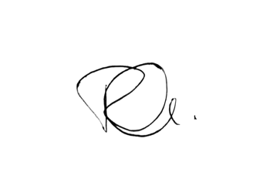

In the presence of.

Name: Confidence Wosu

Address: No.15 Rumuigbo Port-Harcourt

Occupation: Sales Manager

Signature: 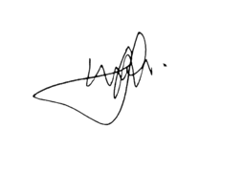

**SIGNED SEALED and DELIVERED**

By the Gudfama

__________________

In the presence of.

Name: ……………………………………………………….

Address: ……………………………………………………..

Occupation: ………………………………………………….

Signature: …………………………………………………….

Prepared by:

Jack Otoibifaa Esq.

NO. 208 Rumuola,

Port Harcourt, River’s state.

08069902316. 08077370465. 07042715386